1. Use function **char getMenu()** for the sample output below:

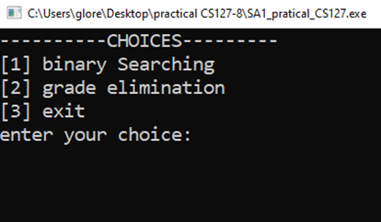

1. **Validate choices using exception handling (try throw catch)** if the user attempts to enter an invalid input ask the user to re-enter the value (see output below)

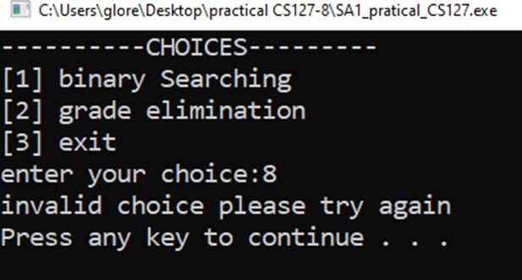

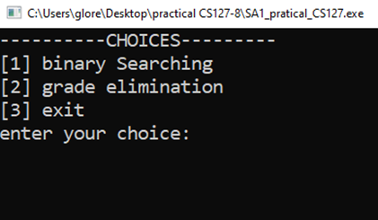

**FOR CHOICE 1: Binary Searching -pointers and exception handling**

1. Use function **void getBinDisplay(int *ptr, int *xsize)** to display the output below

**NOTE: values below are assigned to an array named binNum from the main program

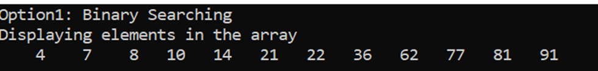

1. Then, use function **int getLoc(int *ptr, int size,int *xtarget)** to process binary searching (you can open google to see the idea on how to process binary searching. (see sample output below)

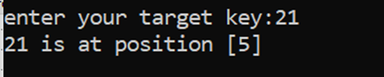

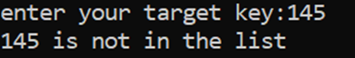

**FOR CHOICE 2: Grade Elimination- dynamic arrays and exception handling**

1. Use function int **getSize()** to enter the desired size for grades (see output below)

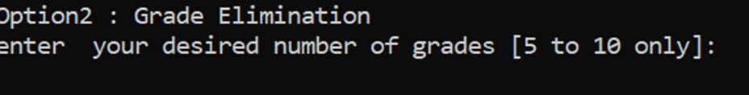

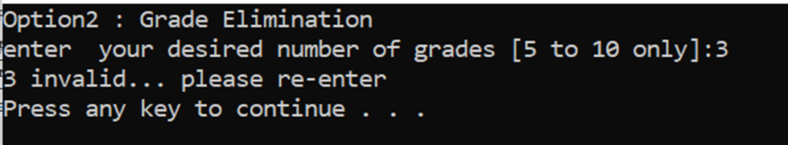

***NOTE: **Validate input using exception handling (try throw catch)** if the user attempts to enter an invalid input ask the user to re-enter the value

1. Use function **void getInput(double *ptr, int xsize)** to populate and input the n number of grades (see below example)

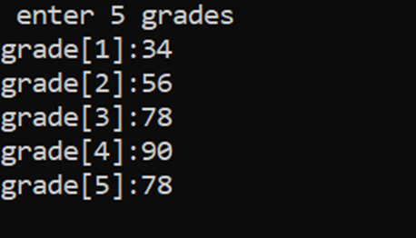

1. Use function **double getElim(double *ptr, int xsize)** to process,eliminate and display to value to be eliminated.Then, output the average in the main program and display the average value in 2 decimal places. (see the output below)

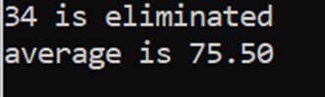

**FOR TRY AGAIN**

1. Use function **void getTry()** to ask the user to try again. (see sample output below)

*** ***NOTE: **Validate input using exception handling (try throw catch)** if the user attempts to enter an invalid input ask the user to re-enter the value

